**Trigger Build on Commit**

**Step1:** Go to the project (need to add Git Plugin)

Now, it is possible to setup a *Build Trigger* to get Jenkins to poll for changes in a Git repository. You do this using the *Poll SCM* option on the project configuration page in Jenkins.

[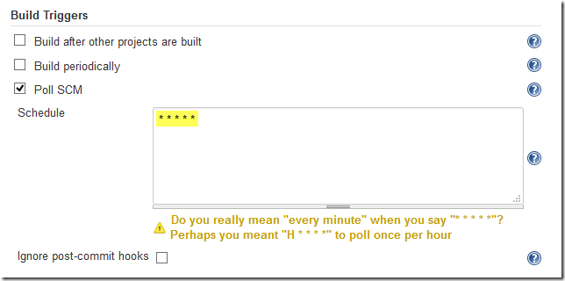](http://lh5.ggpht.com/-akh-geymnqg/VQXVtSLu_1I/AAAAAAAABtw/htp9spnfIDE/s1600-h/jenkins009%25255B3%25255D.png)

**Step2:**

-Inside every Git repository (client git repository) there’s a hidden .git folder. Inside the .git folder is a hooks subfolder.

-Create a post-commit git hook inside the hook folder (.git🡪hook🡪post-commit)

-Add the below to line

**#!/bin/sh**

**curl http://localhost:8080/git/notifyCommit?url=file://D:/GitRepo**

**Step:3**

Once you commit any thing in the code the build will be triggered in the Jenkins.